**NumPy**

* Mainly used for multi-dimensional array
* It has Pre defined mathematical function

1. **Array:**

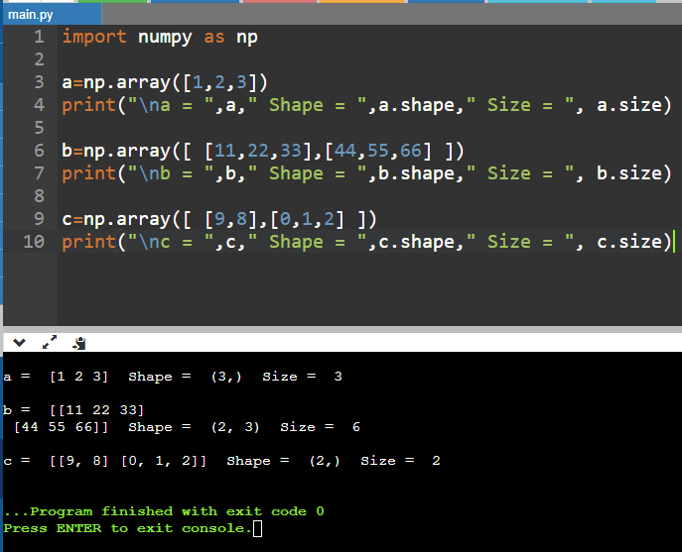

1. **Percentile:**

